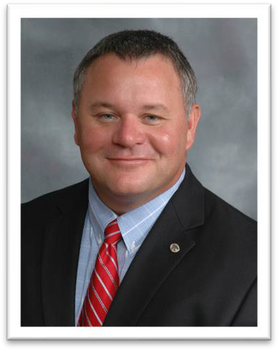
David G. Renter, DVM, PhD

Dr. David Renter is a professor of epidemiology, and the founder and director of the Center for Outcomes Research and Epidemiology in the College of Veterinary Medicine, Kansas State University, where he leads strategic development and implementation of research and training initiatives that enhance a wide-range of population health programs. Dr. Renter has been awarded The Dr. Robert MacDonald Endowed Professorship and was inducted as a Fellow of the Conference of Research Workers in Animal Diseases in 2023. His research emphasizes the application and extension of epidemiologic principles and methods to enable valid data-driven decisions that improve health and well-being, food safety and security, and sustainability of health and production systems. Dr. Renter has collaborated on over $40 million in research grants with academic, government and industry partners, and has published more than 150 peer-reviewed papers. He teaches epidemiology and research methods, mentors students in multiple programs, and has delivered advanced continuing education. He also has leadership roles in several professional organizations including as the President-elect for the Association for Veterinary Epidemiology and Preventive Medicine.

